**Secure Banking Application**

**DATA FLOW DIAGRAM:**

 The flow of data of a system or a process is represented by DFD. It also gives insight into the inputs and outputs of each entity and the process itself. DFD does not have control flow and no loops or decision rules are present.

**LEVEL-0 DFD:**

It's a context diagram that helps map out the flow of information to better visualize processes and systems. It shows the system as a single process with its relationship to external entities.

**Level-1 DFD:**

This level-1 DFD shows a little detailed pictorial description of the secure banking.

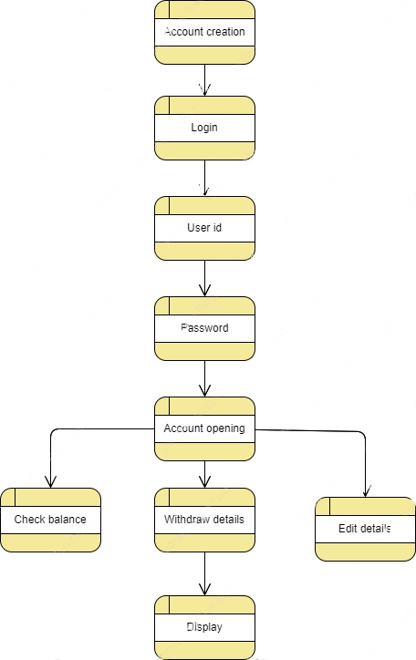

**FUNCTIONAL DIAGRAM:**

Functional diagram is an abstract representation of the product and its inner working, typically used to predict or to specify its performance.

